**Baku Higher Oil School**



**Image Processing**

**Student’s full name:** Rinat Mahmudov

**Group number:** PAE 22.2

**Report submitted on:** 09.19.2025

**Supervisor name:** Leyla Muradkhanli

**Lab work 1. Working with Images**

In this project, eight different operations were performed on a single image using the Python Pillow library. Pillow can be installed from the command line by using the command pip install pillow. After installation, the library can be imported in Python to work with images.

In this lab the photo of the tree was used.

1. First, the image was opened from a file and displayed. 
2. Its format, mode, and size were printed for detailed information.

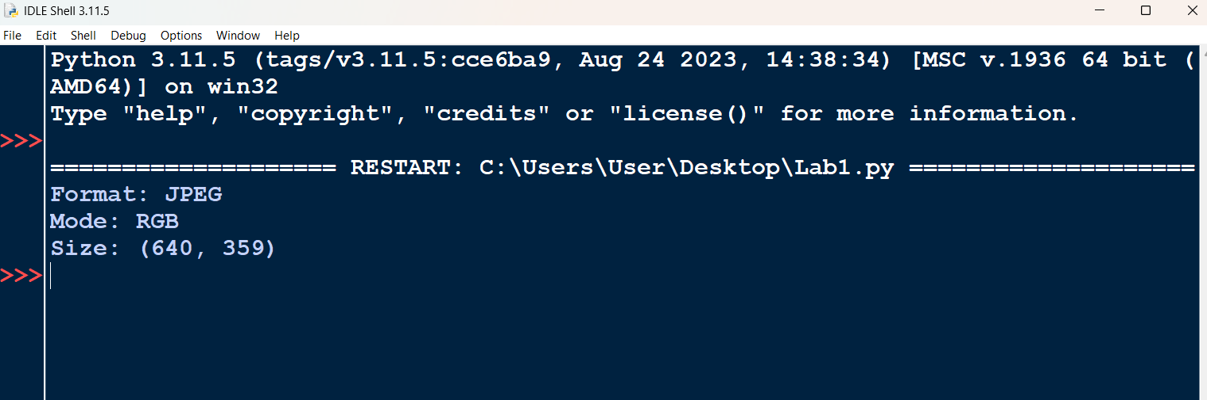

1. The image was then saved again in its original format.
2. Afterwards, the image was resized to 300×200 pixels and stored as a new file.



1. A cropped rectangular region was created from the image and saved separately.



1. The image was rotated by 90 degrees to change its orientation.



1. A mirror version of the image was produced by flipping it from left to right.



1. Finally, the image was flipped upside down to generate a top-to-bottom version.

